Project Development Phase
Model Performance Test

Date | 03 October 2026
Team ID | SWTID-2026-4339
Project Name | Streamlining IT Procurement: Automating Standard Laptop Orders with Flow Designer
Maximum Marks

Model Performance Testing:
Project team shall fill the following information in model performance testing template.
S.No. | Parameter | Values | Screenshot
 | Model Summary | Rule-based ServiceNow Flow Designer automation for standard laptop orders: a catalog request triggers a flow that routes manager approval, creates the procurement task and notifies the requester. No AI/ML model is used. | 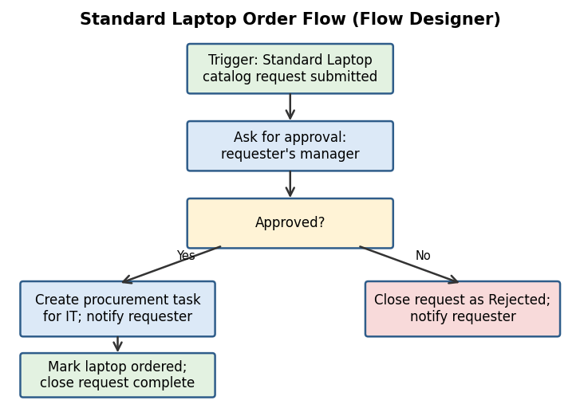
 | Accuracy | Training Accuracy - N/A (no machine learning model)  Validation Accuracy - N/A; validated through testing: 6 of 6 UAT test cases passed (100%) | 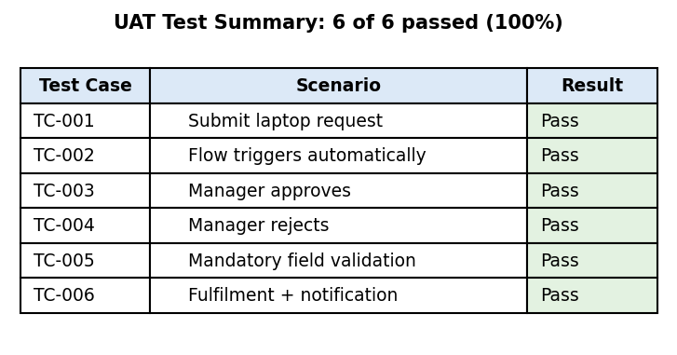
3. | Fine Tunning Result( if Done) | Validation Accuracy - N/A (no model to fine-tune); the flow was validated through functional UAT test cases | 